 What does SAFE Skin to Skin look like?

Position yourself a little upright- not totally flat.

On your bare chest, position your naked baby so that their:

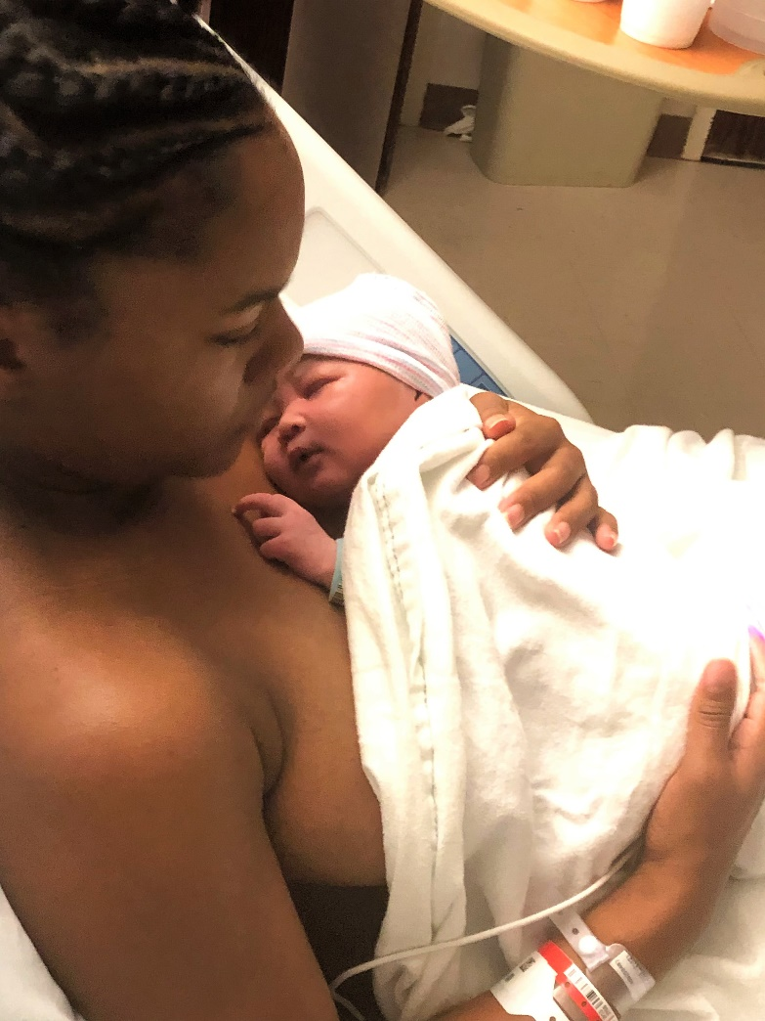

* Shoulders & chest flat against your chest.
* Face can be seen.
* Head can move freely at all times.
* Nose & mouth are not covered.
* Head is turned to the side, so airway is open.
* Neck is straight and not bent.
* Arms & legs are flexed- like a little frog.
* Back is covered with warm, heavy blankets.

*\*\*If you are feeling sleepy and no one can watch you & your baby, place the baby on their back in the crib.*

Is my newborn in an okay position??

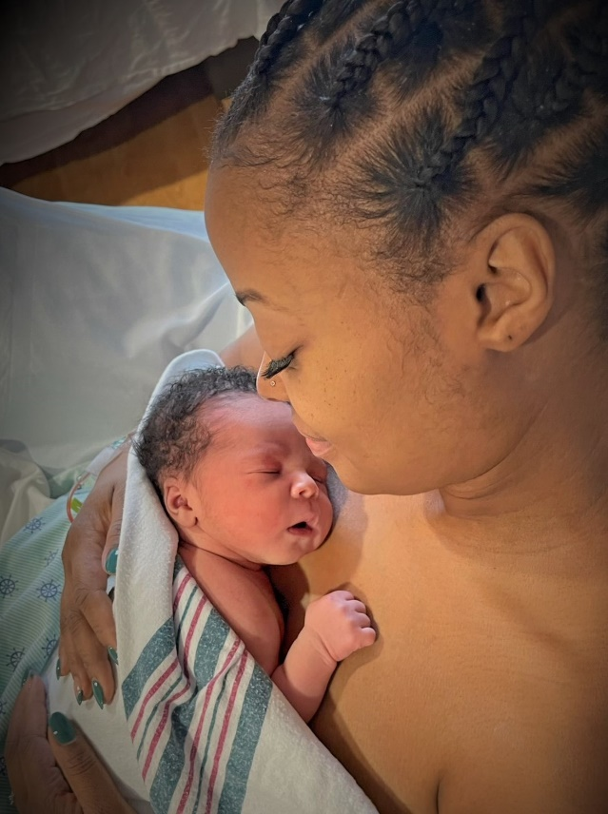Respiratory effort: In baby breathing easily? **Does the baby seem to be struggling to breathe or breathing too fast or slow? Unsure- call for nurse.**

Activity: Is the baby awake or asleep? **Even a sleeping baby will respond to touch or movement. If the baby doesn’t respond, call for nurse.**

Perfusion/Color: Their hands and feet may appear blue or purple and this is expected. But does the baby’s body look “pink”? **Any paleness, grey, blue or dusky color should be evaluated immediately by the nurse.**

Position: Baby should be positioned upright, head turned to the side, mouth and nose visible. Extremities should not be limp. **If baby appears limp- call for nurse immediately.**